Cybersecurity Incident Report:

Network Traffic Analysis By: Prince Afari, Security Reseacher, Web Developer – GCTU.
June 27, 2026.

Part 1: Provide a summary of the problem found in the DNS and ICMP
traffic log.

The UDP protocol reveals that: UDP port 53 on the DNS server was unreachable.

This is based on the results of the network analysis, which show that the ICMP echo reply returned the error message: “udp port 53 unreachable”

The port noted in the error message is used for: DNS services, including translating domain names into IP addresses.

The most likely issue is: the DNS service running on UDP port 53 was unavailable.

Part 2: Explain your analysis of the data and provide at least one cause of the incident.
Time incident occurred: at 1:24:32 pm(13:24:32)

Explain how the IT team became aware of the incident: The IT Team became aware of the incident when clients reported they could not access the company’s website which is www.yummyrecipesforme.com. “destination port unreachable” was the error message they saw after waiting for the page to load.

Explain the actions taken by the IT department to investigate the incident: The IT department attempted to reproduce the issue by visiting the website. They then used tcpdump, a network packet analyzer, to capture and analyze the DNS and ICMP traffic generated while accessing the site.

Note key findings of the IT department's investigation (i.e., details related to the port affected, DNS server, etc.): DNS requests were sent using UDP and were directed to port 53. The DNS server responded with ICMP “UDP port 53 unreachable."

Note a likely cause of the incident: The DNS service on UDP port 53 was unavailable, possibly due to a service outage, server misconfiguration or a firewall configuration preventing access to port 53

This is the attached tcpdump log
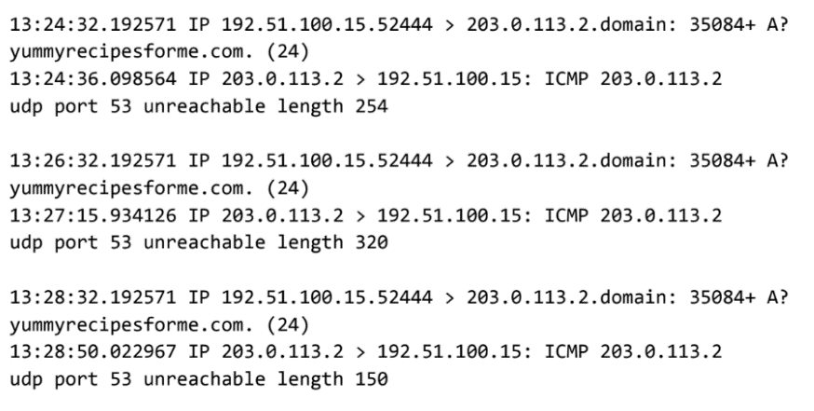
Figure 1: tcpdump analyzer

